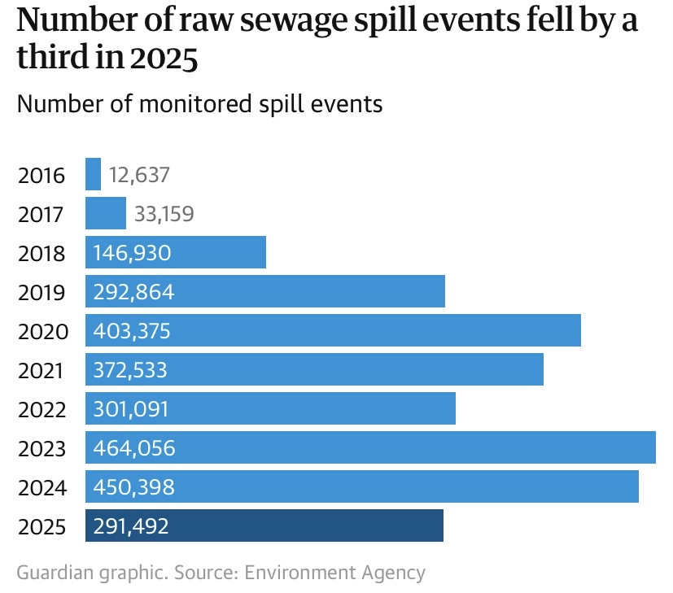 | 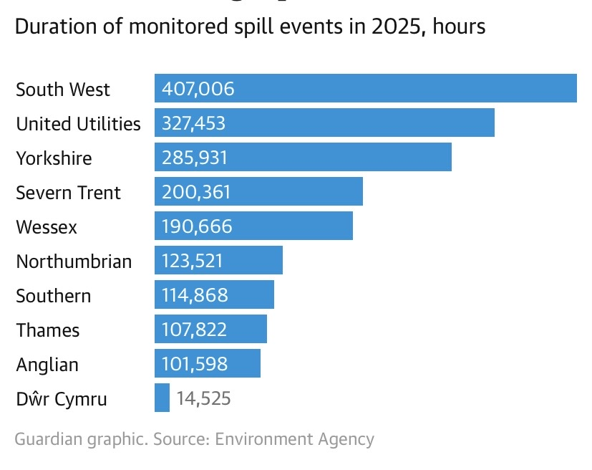
Raw sewage was discharged into rivers and seas almost 300,000 times last year after the driest spring for more than 100 years and the sunniest and warmest year on record in England. Water companies released raw sewage into rivers and seas from storm overflows – designed to be used in extreme wet weather conditions – 291,492 times. This was a 35% reduction on record spills in 2024. Average discharges were 20.5 spills for each overflow, compared with 31.8 in the previous year.
Severn Trent Spills 2012 - 2025
Location Overflow | 2021 spills | 2021 Hours | 2022  spills | 2022  Hours | 2023 spills | 2023 Hours | 2024  spills | 2024  Hours | 2025  spills | 2025  Hours
Severn Trent | 59,662 | 461,119 | 44,751 | 249,111 | 60,253 | 440,446 | 62,085 | 454,155 | 36,471 | 200,361

River Avon (based on overflows with monitoring: STW / The rivers trust 2019 - 2025
Location Overflow | 2019 spills | 2019 hours | 2020 spills | 2020 hours | 2021 spills | 2021 Hours | 2022 spills | 2022 Hours | 2023 spills | 2023 Hours | 2024  spills | 2024  Hours | 2025  spills | 2025  Hours
Warwick (Longbridge) | X | X | 51 | 560 | 71 | 737 | 50 | 444 | 96 | 1,171 | 87 | 840 | 29 | 215
Wellsbourn | X | X | 62 | 679 | 84 | 1655 | - | - | - | - | 224 | 4,007 | 87 | 1509
Tiddington | 42 | 94 | 20 | 16 | 4 | 2 | 1 | 1 | 9 | 5 | 7 | 22 | 3 | 5
Stratford-Shipston road | 6 | 4 | 0 | 0 | 5 | 1 | - | - | 2 | 2 | 7 | 31 | 7 | 24
-Stratford-Banbury road | 6 | 4 | 2 | 4 | 1 | 1 | - | - | 2 | 2 | 11 | 109 | - | -
Stratford-Bridgeway | 7 | 36 | 11 | 24 | 8 | 13 | 8 | 6 | 14 | 18 | 22 | 162 | - | -
Stratford-Paddock Lane | 23 | 72 | X | X | 42 | 175 | 35 | 108 | 62 | 253 | 58 | 325 | 20 | 142
Milcote | 74 | 1206 | 49 | 583 | 33 | 372 | 5 | 19 | 45 | 480 | 36 | 489 | 26 | 193
Weston on Avon | X | X | X | X | 56 | 490 | 40 | 112 | - | - | - | - | - | -
Lower Binton  Evesham road | 0 | 0 | 18 | 150 | 45 | 578 | 29 | 169 | 66 | 778 | 88 | 1062 | - | -
Welford on Avon- Boat Lane | 35 | 174 | 34 | 135 | 49 | 259 | - | - | - | - | 61* | 613* | 30 | 175
Barton road | 22 | 67 | 6 | 17 | 14 | 56 | 8 | 10 | 19 | 53 | 22 | 71 | 14 | 17
Bidford on Avon-High St. | 44 | 925 | X | X | 4 | 3 | 49 | 26 | 45 | 192 | 61 | 422 | - | -

Location Overflow | 2019 spills | 2019 hours | 2020 spills | 2020 hours | 2021 spills | 2021 Hours | 2022 spills | 2022 Hours | 2023 spills | 2023 Hours | 2024  spills | 2024  Hours | 2025  spills | 2025  Hours
Merryfields Farm | 60 | 1099 | 26 | 385 | 0 | 0 | - | - | 14 | 123 | 52 | 861 | - | -
Bidford on Avon  Treatment works | 130 | 2013 | 162 | 2249 | 163 | 3204 | 31 | 49 | 77 | 615 | 192* | 3,040* | 6 | 29
Evesham-Burford road | 10 | 2 | 8 | 1 | 10 | 4 | 7 | 2 | 2 | 0.1 | 4 | 0.3 | 4 | 0.5
Evesham-Lower Leys | 6 | 12 | 4 | 13 | 22 | 56 | 11 | 3 | 10 | 5 | 6 | 1.12 | 9 | 2
Evesham-Battleton Park | 28 | 48 | 30 | 139 | 20 | 125 | 20 | 18 | 20 | 35 | 39 | 206 | 17 | 48
Evesham-Waterside | 7 | 15 | 7 | 11 | 2 | 1 | 10 | 16 | 8 | 12 | 2 | 4 | 9 | 8
Evesham-Abbey road | 30 | 159 | 22 | 138 | 32 | 154 | 31 | 44 | 18 | 45 | 35 | 153 | 10 | 66
Evesham-Hampton syphon | 30 | 121 | 17 | 160 | 28 | 131 | 7 | 17 | - | - | 30* | 172* | 6 | 58
Evesham-Pershore road | 39 | 376 | 31 | 129 | 30 | 71 | 29 | 36 | 39 | 58 | 45 | 71 | 30 | 17
Evesham-Avon St. | 66 | 131 | 61 | 107 | 62 | 101 | 60 | 78 | 10 | 16 | 58 | 152 | 43 | 72
Evesham-Hampton Park | 71 | 445 | 56 | 404 | 44 | 302 | 37 | 123 | 36 | 192 | 54 | 607 | 20 | 183
Cropthorn | 31 | 186 | 2 | 27 | 8 | 43 | 4 | 4 | 15 | 127 | 32 | 302 | 6 | 44
Lower moor | 117 | 1795 | 136 | 2299 | 103 | 1536 | 103 | 995 | 198 | 3,063 | 225 | 4,428 | 18 | 313
Pershore-Wyre road | 60 | 959 | 119 | 2447 | 32 | 462 | 30 | 266 | 54 | 700 | 86 | 553 | 21 | 187

Location Overflow | 2019 spills | 2019 hours | 2020 spills | 2020 hours | 2021 spills | 2021 Hours | 2022 spills | 2022 Hours | 2023 spills | 2023 Hours | 2024  spills | 2024  Hours | 2025  spills | 2025  Hours
Pershore-Defford road | 1 | 6 | 7 | 20 | 16 | 12 | 26 | 26 | 44 | 103 | 52 | 134 | 34 | 118
Defford | 63 | 254 | 47 | 270 | 38 | 146 | 35 | 188 | 36 | 150 | 34* | 252* | 26 | 202
Eckington-Mill Lane | 6 | 47 | 13 | 107 | 21 | 175 | 5 | 8 | 21 | 60 | 36 | 156 | 13 | 38
Bredon | 6 | 4 | 5 | 14 | 6 | 7 | 2 | 2 | - | - | 6 | 25 | 4 | 18
Twyning | 117 | 2159 | 88 | 1453 | 133 | 2696 | 82 | 1229 | 91 | 1,340 | 149 | 1,883 | 49 | 533
Tewkesbury-Red lane | 0 | 0 | 9 | 66 | 2 | 0 | 3 | 1 | 2 | 0.5 | 8 | 10 | - | -
Tewkesbury-Tolsey lane | 3 | 18 | 11 | 98 | 5 | 1 | 6 | 21 | 2 | 0.3 | 10 | 6 | 2 | 1
Tewkesbury-Lower Lode SPS | 139 | 2312 | 99 | 1304 | 81 | 816 | 73 | 529 | 86 | 965 | 110 | 1,292 | 61 | 551
Tewkesbury-Lower lode STW | 60 | 1100 | 56 | 1137 | 51 | 884 | 37 | 558 | 57 | 1,020 | 41* | 551* | 36 | 669

- *Welford on Avon- Boat Lane; This monitor only operated for 68% of the year
- *Bidford on Avon Treatment works; This monitor only operated for 81% of the year
- *Evesham-Hampton syphon; This monitor only operated for 63% of the year
- *Defford; This monitor only operated for 73% of the year
- * Tewkesbury-Lower Lode 2; This monitor only operated for 44% of the year

River Isbourne
Location Overflow | 2020 spills | 2020 Hours | 2021 spills | 2021 Hours | 2022  spills | 2022  Hours | 2023 spills | 2023 Hours | 2024  spills | 2024  Hours | 2025  spills | 2025  Hours
Vineyard St | 12 | 37 | 2 | 2 | 0 | 0 | 1 | 1 | 4 | 3.6 | 1 | 0.2
Winchcombe STW | 68 | 675 | 23 | 221 | 12 | 84 | 40 | 206 | 56 | 421 | 29 | 142
Toddington STW | 66 | 546 | 68 | 426 | 44 | 1532 | 24 | 112 | 74 | 478 | 18 | 113
Wormington STW | 45 | 222 | 20 | 6 | 2 | 1 | 18 | 15 | -- | - | 4 | 4
4Sedgeberrow STW | 4 | 37 | 1 | 8 | 0 | 0 | 2 | 5 | 4 | 14.7 | 3 | 11
Hilton on the Green STW | 114 | 392 | 161 | 196 | 227 | 1314 | 0 | 0 | 100 | 591 | 15 | 71
Pershore rd. CSO | 31 | 129 | 30 | 71 | 29 | 36 | 39 | 58 | 45 | 71 | 30 | 17

Winchcombe STW; This monitor only operated for 53% of the year

River Stour
Location Overflow | 2020 spills | 2020 Hours | 2021 spills | 2021 Hours | 2022  spills | 2022  Hours | 2023 spills | 2023 Hours | 2024  spills | 2024  Hours | 2025  spills | 2025  Hours
Clifford Chambers |  |  |  |  |  |  | 8 | 73 | 28 | 272 | 10 | 87
Mill House PS (Crimcot) | 18 | 76 | 24 | 99 | 23 | 56 | 45 | 236 | 76 | 828 | 17 | 119
Mill Lane PS  Halford | 7 | 68 | 8 | 47 | 2 | 5 | 18 | 135 | 22* | 190* | 11 | 71
Caudlewell  PS Shipton | 9 | 59 | 1 | 1 | 1 | 4 | 33 | 273 | 51 | 538 | 29 | 304
Cherington | 80 | 1233 | 119 | 1929 | 84 | 1010 | 173 | 3,558 | 131* | 2,397* | 44 | 568

- *Mill Lane PS; This monitor only operated for 86% of the year
- *Cherington; This monitor only operated for 80% of the year

Carrant Brook
Location Overflow | 2020 spills | 2020 Hours | 2021 spills | 2021 Hours | 2022  spills | 2022  Hours | 2023 spills | 2023 Hours | 2024  spills | 2024  Hours | 2025  spills | 2025  Hours
Gt Washbourne | 42 | 356 | 45 | 441 | 34 | 178 | 44 | 219 | 128 | 1,088 | 33 | 306
Beckford | 107 | 2061 | 88 | 1297 | 67 | 835 | 56 | 410 | 61 | 510 | 37 | 521
Kemerton PS  (Brook) | 26 | 259 | 73 | 655 | 41 | 163 | 92 | 739 | 118 | 1,725 | 44 | 534
Kemerton Mill | 8 | 26 | 24 | 29 | 13 | 6 | 21 | 27 | 30 | 64 | 19 | 50

Tirle Brook
Location Overflow | 2020 spills | 2020 Hours | 2021 spills | 2021 Hours | 2022  spills | 2022  Hours | 2023 spills | 2023 Hours | 2024  spills | 2024  Hours | 2025  spills | 2025  Hours
Woolstone |  |  | 125 | 605 | 33 | 90 | 79 | 349 | 105 | 735 | 28 | 129
Teddington |  |  | 135 | 1128 | 51 | 423 | 112 | 988 | 145 | 1804 | 53 | 342
Ashchurch |  |  | 4 | 44 | - | - | - | - | - | - | - | -

