SafeAvon.org.uk Update Spring 2026
Why SafeAvon?
In 2025 there were over 386,000 discharges of untreated sewage into UK rivers, totalling over 2,651,969 hours of pollution. Despite drought conditions across the country, this dumping of raw sewage highlights the impact of Water Companies failure to invest in infrastructure over the long term. The Environmental Agency (EA) said much of the reduction was down to the dry weather and emphasised that sustained maintenance and investment in water industry drainage networks was needed to bring lasting improvements. The UK is consistently ranked as one of the worst countries in Europe for water quality, over three quarters of our rivers fail to meet required health standards and face multiple threats.
The poorly maintained sewage system uses Storm Overflows from treatment works, pumping stations and combined sewer overflows from the sewer network to dump raw sewage into our rivers. Lack of investment by water companies means the existing infrastructure can’t cope, which leads to the dumping of untreated sewage into our waterways on a regular basis.
Treated and untreated sewage is the greatest threat to river biodiversity and according to research causes more damage than runoff from farms (Ref. the combined effect of treated sewage discharge and land use on rivers; Albini, et.al.).
What are we testing
- Electrical Conductivity (EC): Conductivity is the ability of water to conduct electricity, which depends on the impurities in the water and is affected by temperature. When a sewage leak or agricultural runoff occurs, it increases the EC because of additional ions such as chloride, phosphate, and nitrate.

- Nitrates: High levels of nitrate in water can be a result of runoff or leakage from fertilized soil, wastewater / sewage, landfills, septic systems, or urban drainage. Nitrate is an essential nutrient, but high concentration in rivers cause serious damage to aquatic ecosystems.

- Phosphate: Excessive phosphorus in water can cause explosive growth of aquatic plants and algae. Leading to a variety of water-quality problems, low dissolved oxygen concentrations causing fish to die & harm other aquatic life. Phosphate (a good measure of sewage pollution) is an essential nutrient, but high concentration cause’s serious damage to aquatic ecosystems.

Interpreting results
Phosphate^{*1} – Orthophosphate (PO₄³⁻) as measured by Hanna Colorimeter
High | Good Ecological Status | Moderate/ Poor
< p.077 ppm | 0.077 – 0.306 ppm | > 0.306 ppm

Nitrate^{*2} – as measured by WaterWorks/Haan Nitrate Test Strips
Natural | Elevated | Excessive
< 1 ppm | 1 – 4.9 ppm | ≥ 5 ppm
ppm = parts per million

Why are we testing

Treated sewage released by water companies into rivers and untreated effluent / sewage that is dumped in rivers via storm overflows are the primary drivers of increased nutrients, algae, and sewage fungus in rivers. Poorly, or untreated sewage cause digestive problems. Linked to the transmission of diarrhoea, dysentery, hepatitis A, and typhoid. Inadequate, or inappropriately managed water and sanitation services constantly expose individuals to preventable health risks

River ecosystem and its biodiversity: Eutrophication: excessive richness or nutrients in a body of water cause a dense growth of plant life. This deprives species of oxygen, with knock-on effects for other species. Rivers are a naturally low nutrients environment, excessive nutrients lead to excessive growth in invasive species, damaging the natural environment.

Bacteria and parasites: Antimicrobial-resistant (AMR) infections currently claim at least 700,000 lives globally– with an estimate of global mortality from AMR across the world by 2050 a staggering 10 million per year. This would represent a greater death toll than cancer and diabetes combined. [Health and Social Care Committee, Antimicrobial resistance, Eleventh Report of Session 2017–19]. Once we have superbugs which are resistant to all known drugs - and we are fast approaching that point - safe surgery, and safe childbirth, will be impossible. even a scratch, can become fatal.

Farm Pollution: Agriculture is a major source of diffuse water pollution (non-point source) because it covers a large area, and the pollutants are essential parts of livestock and arable farming. The farming rules for water focus mainly on the storage and distribution of animal waste and fertiliser to prevent damaging pollutants from farms running into rivers where they can cause algae blooms that lead to oxygen depletion.

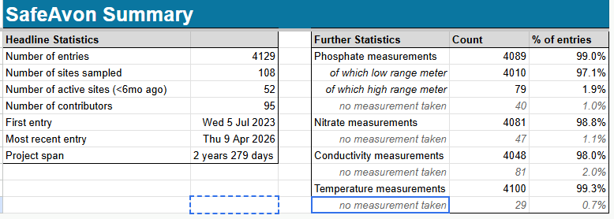

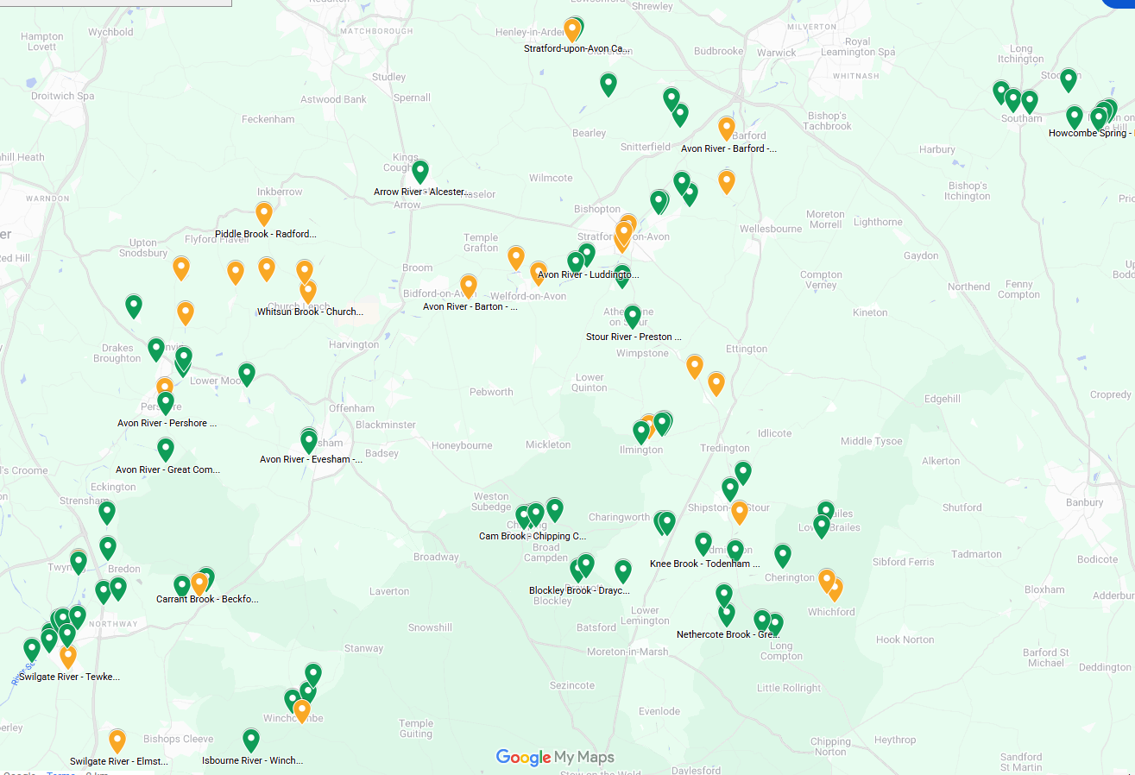

What needs to be done:

- Water companies need to provide full transparency of their data and methods, and to allow independent scientists access, as no one knows for sure what they are doing and how they go about it.

- Stop the spills of raw sewage, 100%. Fix the leaks in the pipes and tanks at the sewage works. Hugely increase the holding capacity of the ponds -as has been done with the super sewer in London. Make sure that the discharge monitors and the control gates are all working - as they are frequently broken.

- Fully fund and ensure the Environmental Agency enforce current environmental legislation (*OEP report Dec. 2025).

- Longer term: Treatment of effluent with UV or ozone – as they do in Switzerland and in the EU by 2035.

How can you help

Write to your MP and tell them how you feel about your Water Companies polluting your communities for high shareholder dividends and bonuses.

If you would like to know more SafeAvon.org.uk or geoffsallis@btinternet.com

*The Office of Environmental Protection (OEP) December 2025 says that the law is clear - but Defra, EA and Ofwat have not applied the law. The OEP has clarified that exceptional circumstances mean ...you guessed it ...exceptional; not as interpreted by Defra and the regulators to date which is that exceptional circumstances are reached when there is a lack of capacity in the sewage system.

"Our investigation found that there had been failures to comply with environmental law by each of the three public authorities relating to the regulation of network CSOs. Decision notices were issued to them setting out the actions required to address the non-compliances. We welcomed responses from them which showed positive action to address the concerns raised and significant progress being made. " https://www.theoep.org.uk/report/oep-reports-investigation-regulation-combined-sewer-overflows

Environment Agency 24-hour Incident Hotline 0800 80 70 60

